**NAAN MUDHALVAN PROJECT REPORT**

**ON**

### “The Future Of University Decision Making With Machine Learning”

### Submitted in partial fulfillment of the requirements for the award of the degree of

**Bachelor of Science**

**In**

**Computer Science**

Submitted By

**Team Leader**

**Marikani R (Reg.No. 20201371506117)**

**Team Members**

**GokilaKumari K (Reg.No.20201371506107)**

**Vaishmathi M (Reg.No. 20201371506145)**

**Vennilakrishna A (Reg.No. 20201371506146)**



Department of Computer Science

Government Arts and Science College for Women, Alangulam

Tenkasi-627 851. April-2023

# The Future Of University Decision Making With

# Machine Learning

# 1.Introduction

Prospective graduate students usually face several challenges identifying universities while applying to master's programs. Most students have difficulty in the graduate admission program as fellow applicants might misinform them or because they are not fully aware of the universities' requirements. Besides, shortlisting all possible universities and their requirements would take much time and might result in the student's missing out the admission deadline. This paper discusses the application of three machine learning algorithms as a method of predicting potential university ratings to admit the students by using data from Kaggle. We compare the performance between the model; Logistic Regression Model in terms of the least error and suggest some direction of further investigations.

## Overview

The world markets are developing rapidly and continuously looking for the best knowledge and experience among people. Young workers who want to stand out in their jobs are always looking for higher degrees that can help them in improving their skills and knowledge. As a result, the number of students applying for graduate studies has increased in the last decade[1]–[4]. This fact has motivated us to study the grades of students and the possibility of admission for master’s programs that can help universities in predicting the possibility of accepting master’s students submitting each year and provide the needed resources. The dataset [5] presented in this paper is related to educational domain. Admission is a dataset with 500 rows that contains 7 different independent variables which are:

Graduate Record Exam1(GRE) score.

The score will be out of 340 points.

Statement of purpose (SOP)

which is a document written to show the candidate's life, ambitious and the motivations for the chosen degree/ university. The score will be out of 5 points.

Letter of Recommendation Strength (LOR)

which verifies the candidate professional experience, builds credibility,

boosts confidence and ensures your competency. The score is out of 5 points

Undergraduate GPA (CGPA)

out of 10

Research

Experience that can support the application, such as publishing research papers in conferences, working as research assistant with university professor (either 0 or 1).

Chance of Admit

One dependent variable can be predicted which is chance of admission, that is according to the input given will be ranging from 0 to 1.

## Purpose

The purpose is among the most challenging forms of material students will have to write in the educational field. People spend most of their time attempting to elaborate on other forms of educational writing, such as research projects and study materials. But now, students must compose a paper about themselves. A statement of purpose (SOP), like any other educational genre, has a systematic structure and framework, and its objective is to demonstrate why the student or the applicant is the finest choice for a specific course or scholarship, as well as why this course or scholarship is the ideal one for them.

## 2.Problem Definition &Design Thinking

# Empathy Map:

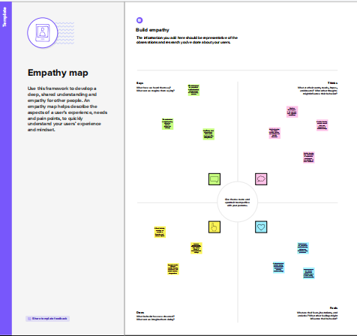

### Ideation and Brainstorming Map:

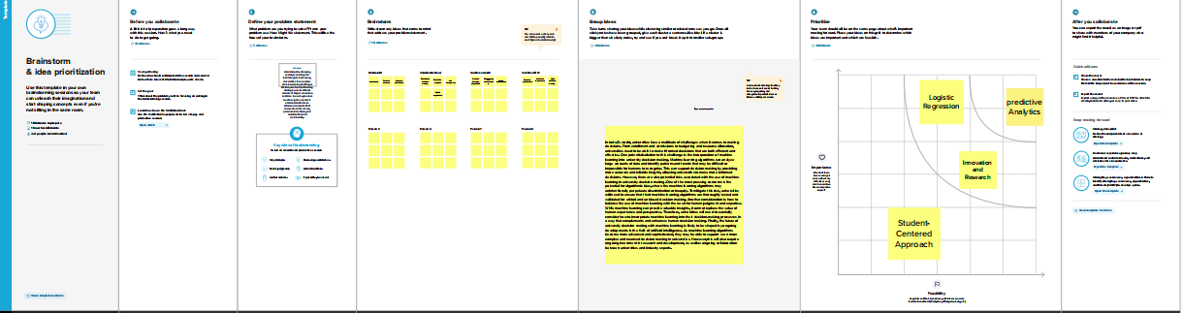

## Result



## ADVANTAGES & DISADVANTAGES

##### Advantages:

Applicants’ Convenience – One of the greatest advantages of the online application system is that applicants can choose to submit their applications at their convenience. All that is required is access to a computer and internet connectivity. Messy handwriting, lack of postal connectivity, delay in courier delivery etc. are unlikely to disrupt the application process. This is a great advantage to candidates in rural areas and candidates with disabilities.

Logistics – No more running out of paper application forms, picking the right colour ink pens, illegible prints and wondering if the application has been received at all. The online application process offers university applicants a uniform platform for filling in their applications and also provides prompts on which fields are mandatory. The acknowledgement is almost immediate and the system user-friendly.

Advantage to Universities – Universities and educational institutions are also at a major advantage when it comes to an online admission process. Quick access to student records and databases, efficient systems for filtering out candidates and processing of applications is possible through the online application process. The costs of processing applications and employing additional manpower during admissions are slashed with the implementation of an online application system.

Increases Accuracy and Efficiency – Those who have seen university officials accepting thousands of paper applications each day at office counters understand that high fatigue and monotony involved in the paperwork is a catalyst for errors. Each error could cost students their academic career and educational prospects. The online admission system is highly reliable and efficient and eliminates chances of such errors.

Demolishing Geography – Another great advantage of the online admission system is that it makes it possible for candidates from across the country and even abroad to apply to Indian universities without any hassles. It eliminates the inconveniences caused by ailments and exigencies, providing deserving candidates a convenience that has never before been available.

##### Disadvantages:

Computer Literacy and Internet Access – In India, though Internet penetration is rather high, Internet connectivity and speed issues are major impediments to bring any real advantage to university applicants. Most rural areas experience high blackouts and electricity issues. This means, once again candidates in urban districts and areas are placed at a significant advantage

Low Computer Literacy – Another major concern is the low rate of computer literacy in India. Current estimates say that only about 6.5 percent Indians are computer savvy. A sudden shift to the online admission process is likely to cause confusion and despondency among a great many applicants.

Security Concerns – In a country like India where security fails of online systems have become increasingly common over the years, online applications make it easier for systems to be breached and for applications or scores to be manipulated. The fear that hackers may target universities and educational institutions is a grave one. Unintentional system failures or server crashes may disrupt the entire admission process of universities and educational institutions. Another important concern is the confidentiality of student information and associated security risks involved in online application processing.

Authenticity – In most manual admission processes, the eligibility of candidates is proved by verification of originals at the time of accepting applications, ensuring that only genuine candidates apply. Online applications make it easier for fraudsters to manipulate the application process and eligibility requirements.

Infrastructural Requirements – Building a robust and secure online admission process is a task that requires financial and infrastructural resources. Many universities and educational institutions may not have the necessary resources and all these costs will ultimately be borne by April-2023 the students. In a country where higher education is a luxury few can afford, increased costs may be a deterrent for education.

## APPLICATIONS

With so many different choices to make, and with each decision you make having a direct impact on your future, applying to university can be quite an intimidating experience, especially if you’re thinking of studying abroad.

However, with careful planning and research, applying to university can be an exciting and rewarding experience, which will help you get into the university of your dreams!

## 6.CONCLUSION

In conclusion, university admissions in the 2023-2024 cycle will continue to be impacted by the shifting priorities of colleges and universities as well as new technologies like Direct Admissions and ChatGPT. Prospective students should be aware of the growing trend toward test-optional admissions, the importance of selecting early action or early decision universities, and the emerging opportunities for creative expression in the application process.

## 7.FUTURE SCOPE

Below mentioned deliverables to be submitted along with other deliverables Record explanation Video for project end to end solution

Project Documentation-Step by step project development procedure Create document as per the template provided.

## 8.APPENDIX

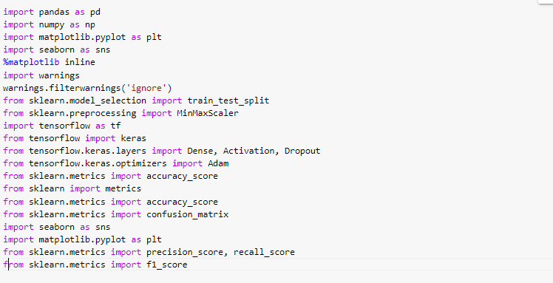

## Screenshot (59)

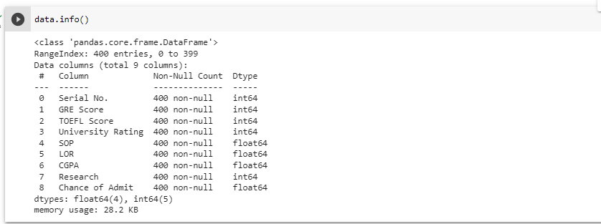

### Screenshot (28)

